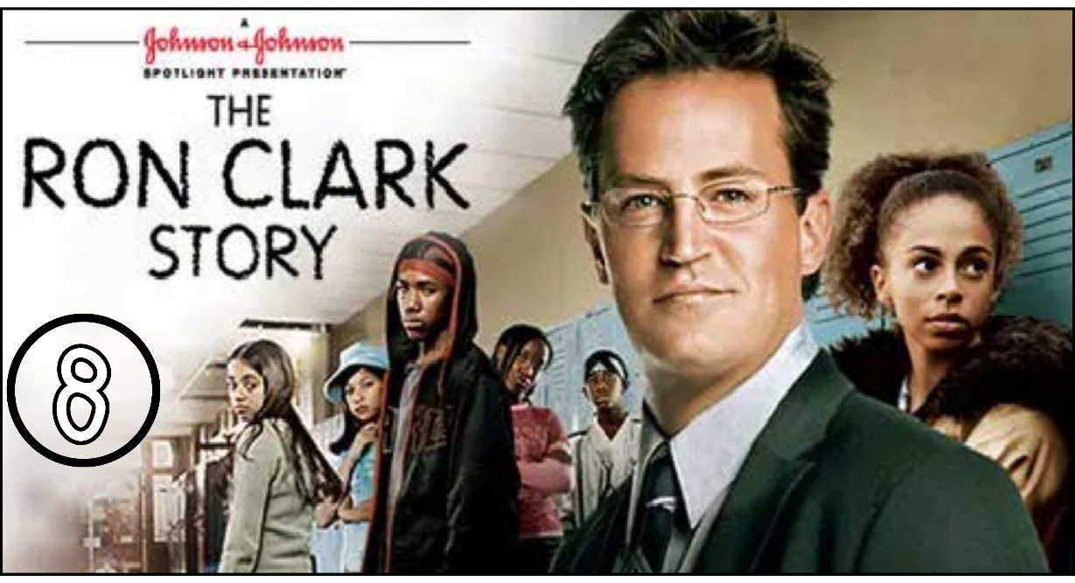
“The Ron Clark Story” (Scene 08)

Part 01 / Work on the Scene

- Scene summary:

“In this scene, Mr. Clark does his best to help his students improve, but unfortunately, not everything goes well. First, Tyshawn didn’t come to the meeting with Mr. Clark because of a misunderstanding. Then, when Mr. Clark was helping Shemeka with her homework, her mother kicked him out of the house—even though he was helping her daughter and taking care of her siblings so she could finish her work.”

- Scene Discussion & Analysis:

- Q01: Who is Tyshawn? And what does he look like?
Tyshawn is Clark’s student. He is a black young boy. He is tall and slim. He has dark eyes.

- Q02: Did he show up at the coffee shop on time?
No, he didn’t.
- Q03: Who showed up instead?
Julio showed up instead of him.
- Q04: Based on your comprehension, why was Mr. Clark inviting his students to the coffee shop?
Mr. Clark invited his students to the coffee shop to give them extra help in some subjects like math and English.
- Q05: Did Shameka turn her homework on time? Why? (based on your understanding)
No, she didn’t. Because she was taking care of here siblings.

Part 02 / Acquired vocabulary & Grammar from the scene

- Acquired Vocabulary (OPTIONAL):

- To bring up (level):
- Example in a sentence:
“I want to bring up my English level.”
- To show up
- Example in a sentence:
“He didn’t show up to the meeting yesterday.”
- Fussy
- Example in a sentence:
“The baby was very fussy because he missed his mom.”

- Irregular Verbs:

Infinitive | Past simple | Past participle
To tell | told | told
To forget | forgot | Forgotten
To bring | brought | Brought
To buy | bought | bought

Part 03 / TRANSCRIPTION: improve your listening (Optional)

Task: Transcribe sentences from the scene.

- Transcribe Sentence 01
- Could bring math and English some extra help tomorrow Saturday I can meet you at the coffee shop by the school. I bay a lunch

- Transcribe Sentence 02
- ... an appointment after school today?

- Transcribe Sentence 03
I tray like you sad I moved the third paragraph and it sounds really good

Open discussion (OQ)

- Topic of discussion: Mr. Clark was so obsessed with his students’ success that he started to get into their personal lives. Do you think that was necessary for every teacher to do? Or do you think that Mr. Clark has crossed all boundaries? And that teachers do not have the right to interfere with their students’ families and personal lives after school? What do you think!?
(Students are free to participate and interact to share their own opinions.)
(Students are encouraged to prepare their arguments before the session.)

